**RHEL6.1_64+ORACLE11G**

操作系统RHEL6.1_64

安装桌面，关闭SELINUX和防火墙，

修改配置文件需要重启机器：

修改/etc/selinux/config 文件

将SELINUX=enforcing改为SELINUX=disabled

重启机器即可

**Chekconfig iptables off关闭**

**1、内存以及swap分区大小**

**Minimum**: 1 GB of RAM

**Recommended**: 2 GB of RAM or more

To determine the RAM size, enter the following command:

#grepMemTotal /proc/meminfo

Swap分区大小设置

Between 1 GB and 2 GB 分配1.5 times the size of the RAM

Between 2 GB and 16 GB 分配Equal to the size of the RAM

More than 16 GB 分配16GB

#grepSwapTotal /proc/meminfo 确定大小

**2、需要安装以下软件**

binutils-2.20.51.0.2-5.11.el6 (x86_64)

compat-libcap1-1.10-1 (x86_64)

compat-libstdc++-33-3.2.3-69.el6 (x86_64)

compat-libstdc++-33-3.2.3-69.el6.i686

gcc-4.4.4-13.el6 (x86_64)

gcc-c++-4.4.4-13.el6 (x86_64)

glibc-2.12-1.7.el6 (i686)

glibc-2.12-1.7.el6 (x86_64)

glibc-devel-2.12-1.7.el6 (x86_64)

glibc-devel-2.12-1.7.el6.i686

ksh

libgcc-4.4.4-13.el6 (i686)

libgcc-4.4.4-13.el6 (x86_64)

libstdc++-4.4.4-13.el6 (x86_64)

libstdc++-4.4.4-13.el6.i686

libstdc++-devel-4.4.4-13.el6 (x86_64)

libstdc++-devel-4.4.4-13.el6.i686

libaio-0.3.107-10.el6 (x86_64)

libaio-0.3.107-10.el6.i686

libaio-devel-0.3.107-10.el6 (x86_64)

libaio-devel-0.3.107-10.el6.i686

make-3.81-19.el6

sysstat-9.0.4-11.el6 (x86_64)

unixODBC*

libXp

pdksh

**配置Yum安装**

yum -y install binutils compat-* elfutils-libelf* gcc gcc-c++ glibc* kernel-headers kshlibaio* libgcc libgomp libstdc++* make sysstat unixODBC* libXp mksh libaio-devel

**3、注意主机名**

[oracle@oracle ~]$ cat /etc/hosts

# Do not remove the following line, or various programs

# that require network functionality will fail.

127.0.0.1 oracle11glocalhost.localdomainlocalhost

::1 localhost6.localdomain6 localhost6

172.16.40.30 oracle

**4、建立用户和组**

[root@oracle ~]# groupadd oinstall

[root@oracle ~]# groupadd dba

[root@oracle ~]# useradd -g oinstall -G dba oracle

[root@oracle ~]# passwd oracle

[root@oracle ~]# id oracle

uid=501(oracle) gid=500(oinstall) groups=500(oinstall),501(dba),503(asmdba)

**5、修改/etc/sysctl.conf文件，添加以下内容**

net.ipv4.ip_local_port_range= 9000 65500

fs.file-max = 6815744

kernel.shmall = 10523004

kernel.shmmax = 6465333657

kernel.shmmni = 4096

kernel.sem = 250 32000 100 128

net.core.rmem_default=262144

net.core.wmem_default=262144

net.core.rmem_max=4194304

net.core.wmem_max=1048576

fs.aio-max-nr = 1048576

# /sbin/sysctl -p 执行该命令，使修改生效

**6、在/etc/pam.d/login配置文件中添加：**

session required pam_limits.so

**7、在/etc/profile配置文件中添加：**

if [ $USER = "oracle" ]; then

if [ $SHELL = "/bin/ksh" ]; then

ulimit -p 16384

ulimit -n 65536

else

ulimit -u 16384 -n 65536

fi

fi

**8、再在/etc/security/limits.conf配置文件中添加：**

oracle soft nproc 2047

oracle hard nproc 16384

oracle soft nofile 1024

oracle hard nofile 65536

oracle soft stack 10240

**9、配置oracle用户的环境变量**

**在/home/oracle/.bash_profile配置文件中添加：**

umask 022

TMP=/tmp

TMPDIR=/tmp

PATH=/bin:/usr/bin:/usr/local/bin:/usr/X11R6/bin

LD_LIBRARY_PATH=/usr/lib:/usr/X11R6/lib

ORACLE_BASE=/u01/app/oracle

ORACLE_HOME=$ORACLE_BASE/product/11.2.0/db_1

ORACLE_SID=orcl

LD_LIBRARY_PATH=$ORACLE_HOME/jdk/jre/lib/i386:$ORACLE_HOME/jdk/jre/lib/i386/server:$ORACLE_HOME/rdbms/lib:$ORACLE_HOME/lib:$LD_LIBRARY_PATH

PATH=$ORACLE_HOME/bin:$PATH

NLS_LANG="AMERICAN_AMERICA.ZHS16GBK"

export ORACLE_BASE ORACLE_HOME ORACLE_SID LD_LIBRARY_PATH PATH NLS_LANG TMP TMPDIR

**11、建立相应目录**

[root@oracle ~]# mkdir -p /u01/app/oracle

[root@oracle ~]# chown -R oracle:oinstall /u01

[root@oracle ~]# chmod -R 775 /u01

至此，整个环境搭建完毕。如果可以，建议重启系统。

接下来下载oracle11g版本安装包

linux.x64_11gR2_database_1of2.zip

linux.x64_11gR2_database_2of2.zip

使用unzip解压，然后进入database目录里面执行安装程序

[oracle@oracle ~]$ cd database/

[oracle@oracle database]$ pwd

/home/oracle/database

[oracle@oracle database]$ **./runInstaller**

**如果出现错误**

[oracle@oracle database]$ ./runInstaller

Starting Oracle Universal Installer...

Checking Temp space: must be greater than 120 MB. Actual 25233 MB Passed

Checking swap space: must be greater than 150 MB. Actual 3999 MB Passed

Checking monitor: must be configured to display at least 256 colors

>>> Could not execute auto check for display colors using command /usr/bin/xdpyinfo. Check if the DISPLAY variable is set. Failed <<<<

Some requirement checks failed. You must fulfill these requirements before

continuing with the installation,

那么切换到root用户运行xhost +

然后再切换oracle用户安装。

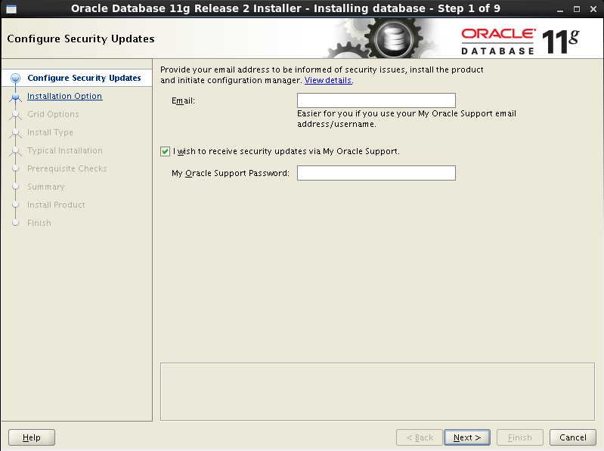

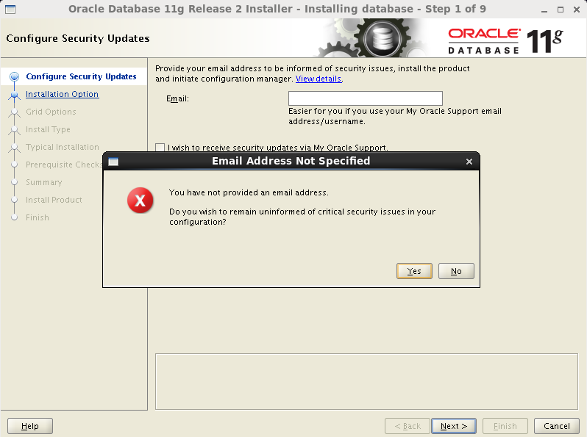

先选择安装数据库，等下用dbca创建实例

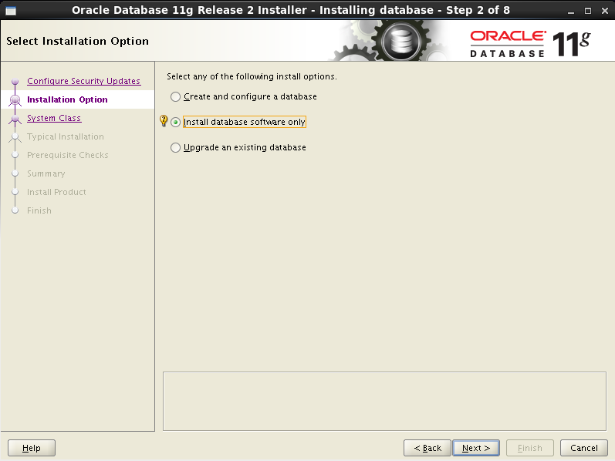

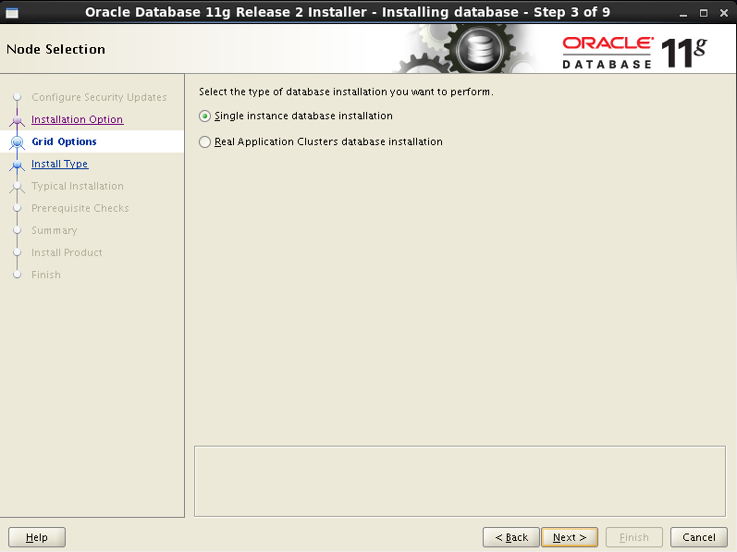

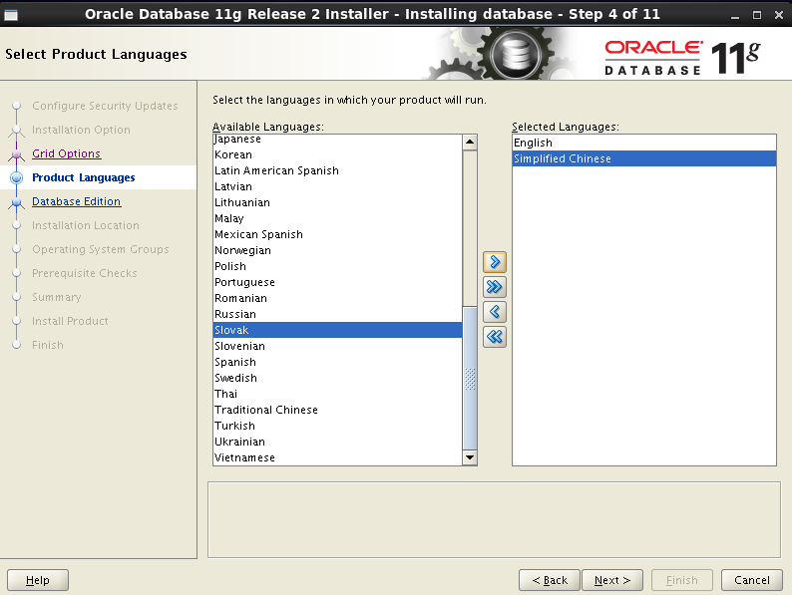

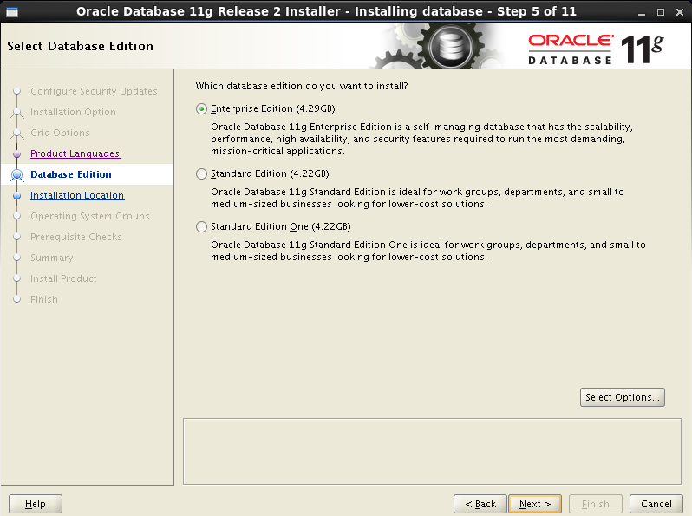

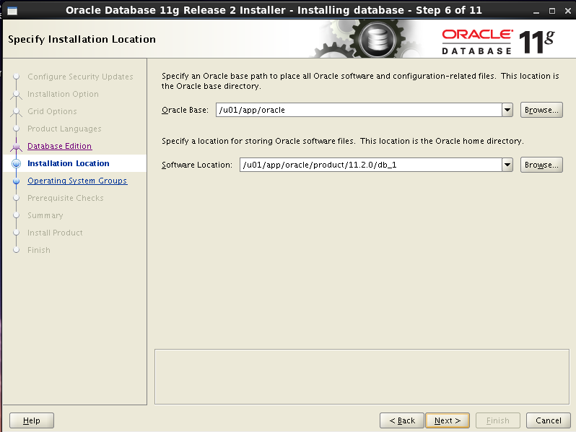

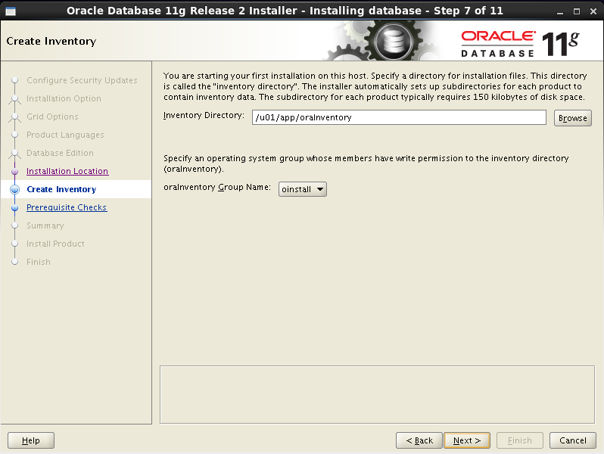

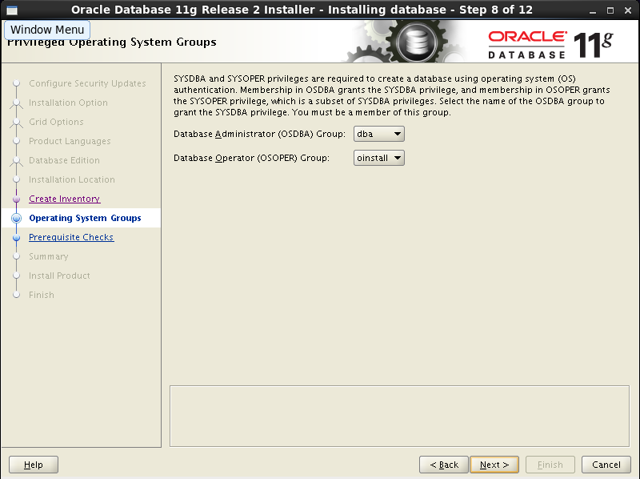

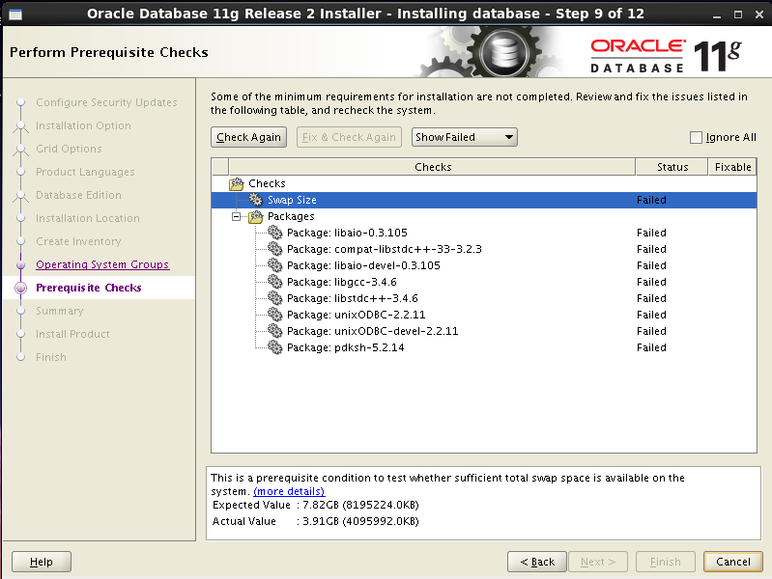

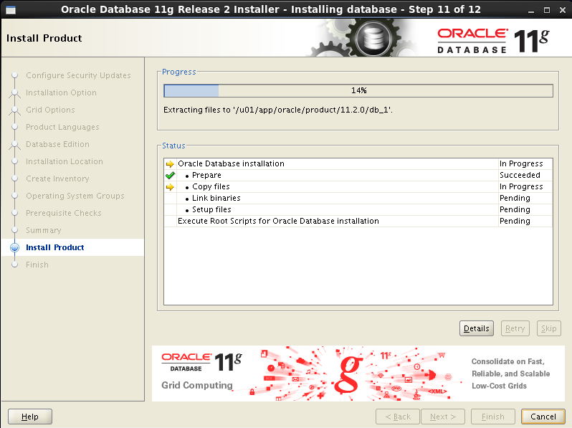

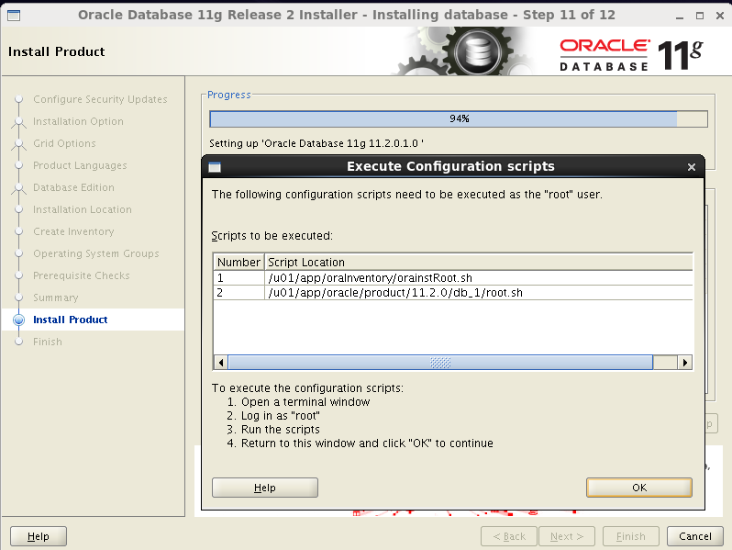

接下来，使用root用户登陆系统，找到这两个脚本，执行下

[root@oracle ~]#**cd /u01/app/oraInventory/**

[root@oracleoraInventory]# ls

ContentsXML logs oraInst.locoui

install.platformoraInstaller.properties orainstRoot.sh

[root@oracleoraInventory]# **./orainstRoot.sh**

Changing permissions of /u01/app/oraInventory.

Adding read,write permissions for group.

Removing read,write,execute permissions for world.

Changing groupname of /u01/app/oraInventory to oinstall.

The execution of the script is complete.

[root@oracleoraInventory]# **cd /u01/app/oracle/product/11.2.0/db_1/**

[root@oracle db_1]# ./root.sh

Running Oracle 11g root.sh script...

The following environment variables are set as:

ORACLE_OWNER= oracle

ORACLE_HOME= /u01/app/oracle/product/11.2.0/db_1

Enter the full pathname of the local bin directory: [/usr/local/bin]: 回车

Copying dbhome to /usr/local/bin ...

Copying oraenv to /usr/local/bin ...

Copying coraenv to /usr/local/bin ...

Creating /etc/oratab file...

Entries will be added to the /etc/oratab file as needed by

Database Configuration Assistant when a database is created

Finished running generic part of root.sh script.

Now product-specific root actions will be performed.

Finished product-specific root actions.

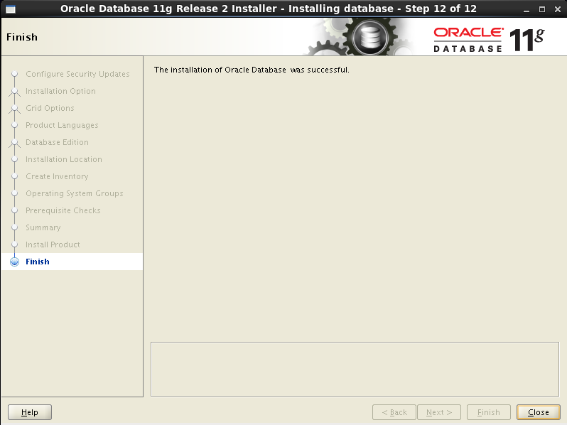

到这里，数据库安装过程结束，但是目前没有实例，我们使用dbca命令来创建实例

Dbca执行的时候如果出现No protocol specified，那么返回到root用户继续执行xhost +

